# LuckDAO White Paper

## Abstract

LuckDAO is a DAO started by a group of people believing that luck is a good nature for society. Luck brings hope, excitement and sometimes great passion. In Hayek's opinion, luck influences society and contributes to its realization of social justice. Luck is also a key idea for business and society, but its positive value seems underestimated by society. LuckDAO wants to present the deep and bright aspects of luck to the public.

## Mission of LuckDAO

1. Transparency and fairness

Lottery in itself is a daily act of many people, bringing a small shining hope when they buy a lottery ticket. Yet, there are countless lottery scandals, rug pull, insider cheater, fake tickets. Even for an honest lottery, it may formulate complex rules to decrease the reward ratio. One mission of LuckDAO is to change this situation, to give a transparent and fair lottery game. LuckDAO Lottery is our first product to show the feasibility to build a competent Luck product using the components of web3. Components as follow:

* Token, NFT, Time-lock, Voting
* Atomic transaction
* Verifiable random number generator
* Decentralized real-life data feeds (Chainlink, API3, Flux…)

may help to build fascinating luck products. The transparency and undeniability of blockchain form the base stone of all LuckDAO products.

1. Make more fun to play with luck in everyday life

We aim to bring experiences of luck events to daily life. We’re willing to push our boundary from online web3 to a metaverse to enhance the experience of our Luck Games.

1. Change the way to understand “Luck”

We hope the idea of luck helps people be relieved and positive, like Zen Buddhism.

We also hope everyone enjoys the win-win part, not just focusing on the lucky winner.

We hope the activities of LuckDAO will bring cognition of and respect for different values.

## Roadmap

LuckDAO creates opportunities for organizations and people around the world to explore how luck can benefit them in fun and entirely legal ways.

LuckDAO consists of 3 Lucky Pillars for the start:

● Luck Lottery

● Lottery as a Service

● Metaluck: Casino as a Service

This diagram demonstrates the relation between the 3 Lucky Pillars (in green) and the Luck Treasury.

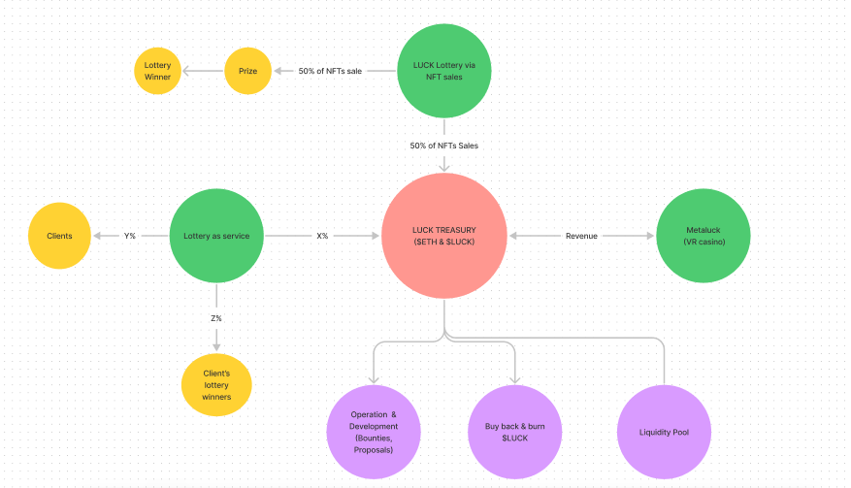

1. Luck Lottery:

Lottery through NFT as a raffle ticket, The Luck Lottery will be regularly and predictably scheduled based on market demand. Luck Lottery will prove to be a transparent and fair lottery game. The committee will keep Luck Lottery in line with laws, setting the example for Lottery Service.

1. Lottery as a Service:

Lottery as a Service is our 2nd Lucky Pillar. In order to offer a legal lottery or sweepstakes that minimizes the risks to the organizer and the winner(s), there are laws in many countries that must be considered, a legal entity to conduct the business, and a need to attest that the lottery was fair. This is a complicated & time-consuming body of work for DAOs to do themselves.

LuckDAO understands the challenges and will offer Lottery as Service packages as well as add-on services such as consulting, NFT creation, access to our curated list of NFT artists, and more. The LuckDAO Lottery as a Service not only eliminates the need for extensive and expensive legal services, it provides a verifiable, 3rd party solution built on transparency and trust.

1. Metaluck

Metaluck is an ambitious effort to create luxurious and delightful experiences that involve luck in the metaverse, starting with the creation of the Metaluck Lounge; an exclusive experience for our Founders Circle Card holders. LuckDAO will take the advantage of the relations with real deal casinos.

Metaluck will gradually extend to common players with an extraordinary experience. Making more fun of luck games with reach is the final goal of Metaluck. Metaluck will be committed to bringing about more gameplay with new techs.

These 3 Lucky Pillars are the keystone to bring positive cash flow for LuckDAO. They are also the key to fulfilling the first 2 missions of LuckDAO.

Other investments and donations

LuckDAO will cooperate with other Programs/DAOs that involve luck elements, sharing experiences. LuckDAO will invest and support them from finance and community aspects.

Programs/DAOs, which are not only for fun but also educative and cultural, are welcomed in LuckDAO’s support plan.

Finally, the roadmap will be printed by the LuckDAO community. It will evolve as web3’s ecosystems develop and LuckDAO members’ vision gets more far-reaching.

## Governance

LuckDAO will apply a hybrid governance model which inherits the advantages of both on-chain & off-chain governance.

The LuckDAO community governs itself via the LuckyCoin. As a DAO we put a high priority on the community's voices, which is why we will create channels for our talented community to grow new ideas, make proposals & execute for the sake of LuckDAO.

On the other hand, we want to move fast and make progress so that we can earn trust from the community and attract more people from around the world. To support this, we created the Luck Committee that is made up of the LuckDAO founders. The mission of the Luck Committee is to steward the growth and development of the Luck ecosystem in a sustainable and inclusive way.

The committee will gradually transfer most powers to the community and turn to an executive board, once the Luck ecosystem becomes prosperous and steady.